The Islamia University of Bahawalpur
Project Proposal
(SCOPE DOCUMENT)
for
Travel Agency & Hotel Room Booking
Version 1.0
Department Information Technology
Faculty of Computing
Submit By:
Muhammad Shah
S25BINFT7M04002
Submitted To:
Dr Suleman SHB
SCOPE DOCUMENT REVSION HISTORY


Supervisor Signature Date:

Catalog
Abstract: 4
Introduction: 4
Problem Statement: 4
Problem Solution for Proposed System: 5
Related System Analysis/Literature Review: 5
Advantages/Benefits of Proposed System: 6
Scope: 6
Modules: 6
1. Destination Guide Module: 6
2. Booking Module: 6
3. User Profile Module: 7
4. Search and Filter Module: 7
5. Review and Rating Module: 7
6. Real-time Information Module: 7
7. Content Management Module: 7
8. Admin Module: 7
System Limitations/Constraints: 7
Software Process Methodology: 8
Tools and Technologies: 8
1. PHP 8
Mockups: 9
Travel Guide Agency Look Like This: 9
First: 9
Second: 10
Conclusion: 11
References: 12
Plagiarism Detection Report 12

Abstract:
The goal of this project is to design and develop a user-friendly and informative travel guide agency website that provides comprehensive travel information and booking services to users. The website will cater to the needs of travelers seeking information about popular tourist destinations, accommodation, transport and activities. With a robust content management system and integrated booking services, the website will enable users to plan and book their trips efficiently.

Introduction:
In today's digital age, the travel industry has seen a significant shift towards online platforms. Travelers are increasingly relying on the Internet to plan and book their trips, and obtain information about destinations, accommodations, transportation, and activities. To meet this growing demand, a travel guide agency website can provide a comprehensive and user-friendly platform for travelers to find and book their dream trips. With the increasing popularity of online travel agencies, there is a need for a website that provides accurate and latest travel information along with seamless booking services. The travel guide agency website will strive to meet this need, providing users with a reliable and efficient platform for planning and booking their trips.

Problem Statement:
The primary challenges in the current travel booking landscape are:
Users must often visit multiple websites (for flights, hotels, and tours) to complete a single trip itinerary
.Inventory and pricing are not always updated in real-time, leading to booking cancellations or disputes.
Existing systems can be complex for travel agents to manage, hindering quick updates and personalized customer service.

Problem Solution for Proposed System:
The proposed system will solve these problems by:
Providing a single platform for booking flights, hotel rooms, and pre-packaged tours.
Utilizing MySQL and PHP/JS for dynamic, real-time updates of room availability, pricing, and flight status.
Offering a dedicated, secure Admin Panel for travel agents to easily manage inventory, track booking, and communicate with customers.

Related System Analysis/Literature Review:
Similar systems such as Expedia, Booking.com and local travel agency portals have successfully proven market demand for online booking. However, many global giants focus heavily on either flights or hotels, while local agencies often lack strong technology.
Our system aims to combine the technical strength of global platforms with the personalized, comprehensive service model of a local travel agency, creating a powerful hybrid solution.
Table 1 Related System Analysis with proposed project solution:
Application Name | Weakness | Proposed Project Solution
- Expedia  - TripAdvisor  - Google Trips  - Lonely Planet | - Limited personalization options, generic recommendations.  - User reviews may not be trustworthy or authentic, limited real-time information.  - Limited integration with booking services, may not provide comprehensive destination guides.  - Limited real-time information, may not provide seamless booking services. | - Advanced personilzation features, tailored recommendations based on user preferences and interests.  - Verified user reviews and ratings, real-time updateson travel alerts, weather, and other relevant information.  - Seamless integration with booking services, comprehensive destination guides with detailed information and images.  - Real-time updates on travel alerts, weather, and other relevant information, seamless booking services with integrated payment options.

Advantages/Benefits of Proposed System:
- Using open-source technologies (PHP, MySQL, JS) minimizes initial licensing and operational costs.
- The unified platform and robust filtering save time, increasing conversion rates.
- Real-time synchronization eliminates overbooking and pricing errors.
- Automated booking confirmations and a centralized Admin Module reduce manual workload.
- The Review and Rating Module builds social proof and credibility.

Scope:
The Travel Guide Agency will include the following functionalities:
- Customer registration and secure login.
- Search functionality for flights, hotels, and tour packages.
- Real-time room availability and pricing display.
- Secure online booking and payment processing.
- Booking confirmation and email notification.
- Admin dashboard for managing users, inventory, and bookings.
- Basic reporting on sales and occupancy rates.

Modules:
The system will be divided into the following modules:
- Destination Guide Module:
To provide users with comprehensive information and inspiration about various travel destination to aid in planning and decision-making.
- Booking Module:
To manage the secure reservation and payment process for selected travel services (flights, hotels, tours).

3. User Profile Module:
To allow registered users to manage their personal information, track booking, and personalize their experience.

4. Search and Filter Module:
To enables users to efficiently find specific travel options based on various criteria.

5. Review and Rating Module:
To build trust and aid decision-making by allowing users to share feedback on hotels and tour packages.

6. Real-time Information Module:
To ensure data accuracy and currency, minimizing booking errors and discrepancies.

7. Content Management Module:
To allow Admins to easily manage all static and dynamic content on the website without needing developer intervention.
- Admin Module:
The central control hub for system management, configuration, and data oversight.

System Limitations/Constraints:
Payment Gateway Reliance: The system’s payment functionality is dependent on the stability and availability of the chosen third-party payment gateway.
Initial Inventory: The initial inventory (hotels, flights) will be manually loaded and managed by the Admin, limiting the initial range of offerings.
Scalability: While MySQL is highly scalable, the initial architecture is designed for a moderate transaction volume and may require optimization for extremely high concurrent user loads.
No Multiple-Language Support: The system will initially only support one language (e.g., English).

Software Process Methodology:
The project will use the Agile/Scrum Methodology. This approach is ideal rapid development and flexibility, allowing for continuous customer feedback and incremental feature releases.
Sprints: Features will be broken down into short, time boxed iterations called sprints.
Daily Stand-Ups: Brief daily meeting to coordinate efforts and identify roadblocks.
Customer Feedback: Regular feedback sessions will be held after each sprint to ensure the system meets evolving business needs.

Tools and Technologies:
The project will utilize the following technologies:
- Front End:
Structure: PHP , HTML , JavaScript
Styling: CSS
- Back End:
- PHP
- JavaScript (JS)
- Database:
- MySQL
- Development Tools:
- XAMP/WAMP (Local testing)
- VS Code, Git/GitHub

Example:
Table 2 Tools and Technologies for Proposed Project
Tools And  Technologies | Tools/Technology | Tools | Rationale
 | Front-end development | PHP,HTML, CSS,  JavaScript | For structuring, styling and adding interactivity to web pages
 | Back-end  development | PHP,JS | For server side scripting and interacting with the DB
 | Database  Management | MySQL | For storing and retrieving data on destinations, users, and bookings
 | Development Tools | XAMP/WAMP  VS Code, Git/GitHub | For local testing and code writing platform

Mockups:
The following mockups illustrate the layout and design of the Travel Agency and Hotel Room Booking System:
1. Home Page: A wireframe of the home page, showcasing the search bar, featured destinations, and call-to-action buttons.
2. Destination Page: A visual representation of a destination page, including images, descriptions, and booking information.
3. Search Results Page: A wireframe of the search results page, displaying a list of destinations and activities matching the user's search criteria.
4. Booking Page: A mockup of the booking page, outlining the booking process and payment information.

Travel Guide Agency Look Like This:

First:
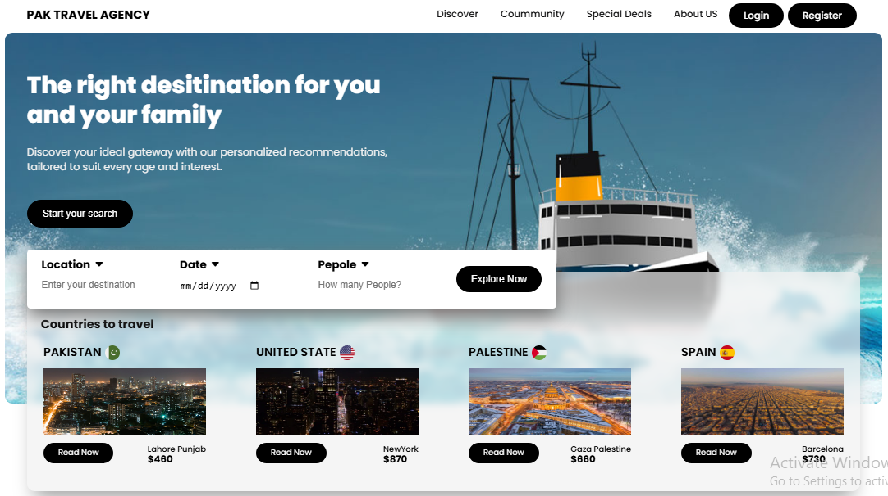

Second: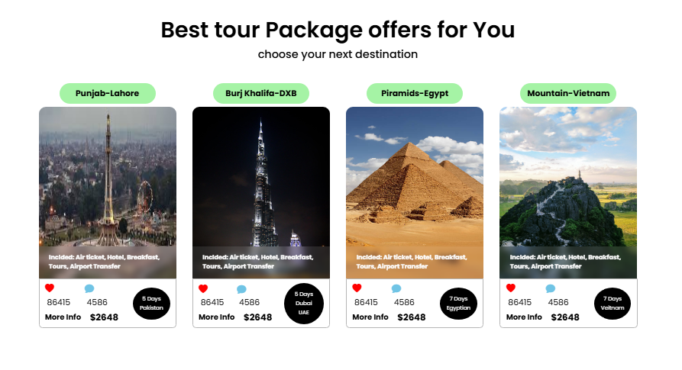Third: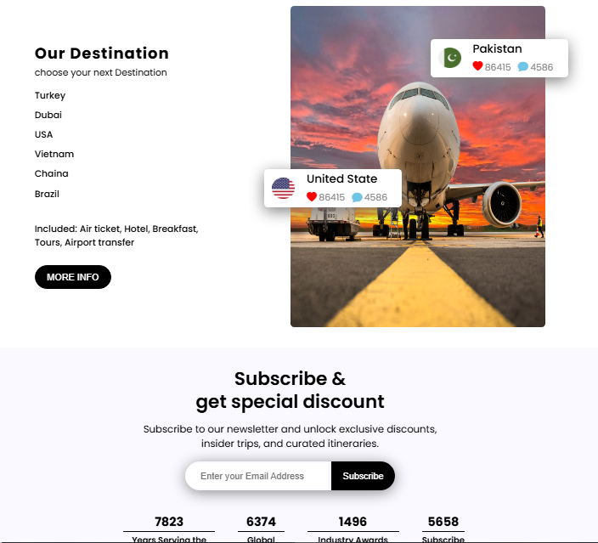

Conclusion:
“Travel Agency and Hotel Room Booking System” project will provide a robust, cost effective and centralized platform using PHP, JS, MySQL. The system will significantly improve operational efficiency for the travel agency and provide an enhanced, seamless booking experience for the customer, positioning the agency for market growth.

References:
- W3Schools and official PHP/JS documentation for technical implementation standards.
- MySQL documentation for database design and optimization.
- Project documentation for comparable online travel agencies (OTAs).

Plagiarism Detection Report
